# Document for Project

# “FoodBox – Online food delivery application”

Version 0

Date 28/May/2021

**Created By**: Sonali Parab

Project for Phase-6: Capstone Project

Table of Contents

Document for Project 1

“SportyShoes.com Admin portal” 1

1. Project and developer details 3

2. Sprints planned and the tasks achieved in them 3

3. Functionalities and Flow of the application 4

4. Core Concepts and tools used in the project 10

5. Link to the GitHub repository 10

6. Conclusion 11

# Project and developer details

**Project** : “Sporty Shoes” is a company that manufactures and sells sports shoes. They have a walk-in store, and now, they wish to launch their e-commerce portal sportyshoes.com. The system a is a prototype of the application. It allows an Admin user to login and manage products, view and search customers and change password for the Admin account.

Foodbox is a restaurant chain that delivers food items of different cuisines at affordable prices. They have decided launch an online food delivery web application with a rich and user-friendly interface. The system provides different functionalities for admin and non-admin users. Admin user is able to manage products, while any registered user can view menu, select items and checkout the items added to the cart.

**Developer** : Sonali Parab

**Estimates**: 21 Days

## Sprints planned and the tasks achieved in them

Planned three sprints as below, each sprint of 20 days duration. The sprint’s details with the story points are as listed in the below screenshots:

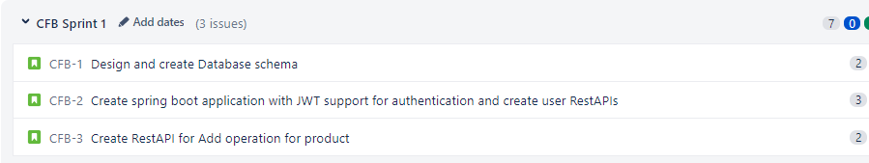

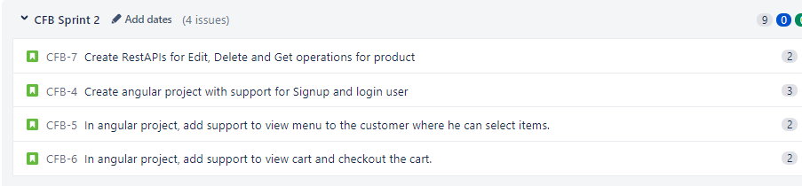

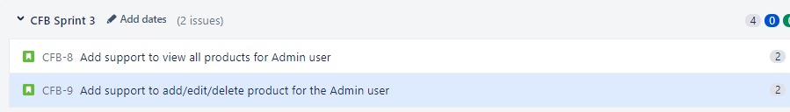

## Functionalities and Flow of the application

It is a web portal that can be used by Admin user or a non-Admin user. As per the type of user, functionalities are made available to the user. An Admin user has added functionality to “**Manage Products**”, where in the admin can add/delete/edit/view products. All the user need to be first registered with the portal. Then on login both Admin and non-admin user can view “**Menu**” and place the order for food delivery.

All the functionalities are available on the navigation bar to the user. Also links for “**Home**” and “**Log Out**” are provided there.

The functionalities or flows included in the web application from “**Home**” page are as depicted in the below screenshots:

* 1. Home Page (Not logged in)

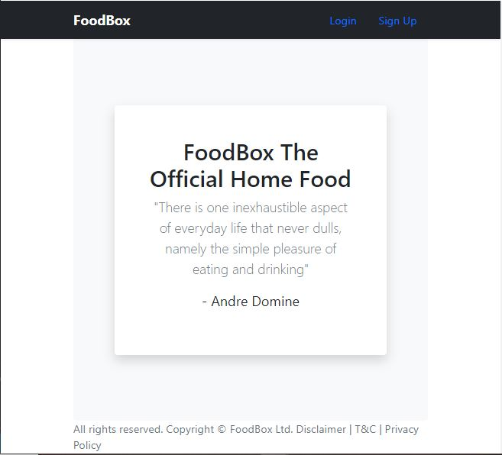

* 1. Sign Up Form

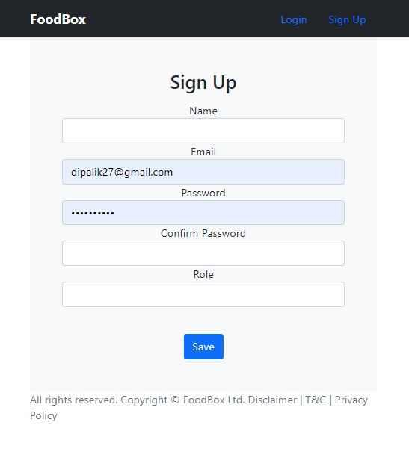

* 1. Sign In

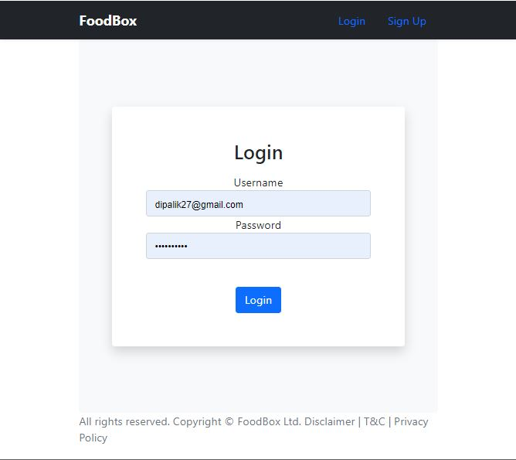

* 1. Manage Products (view all)

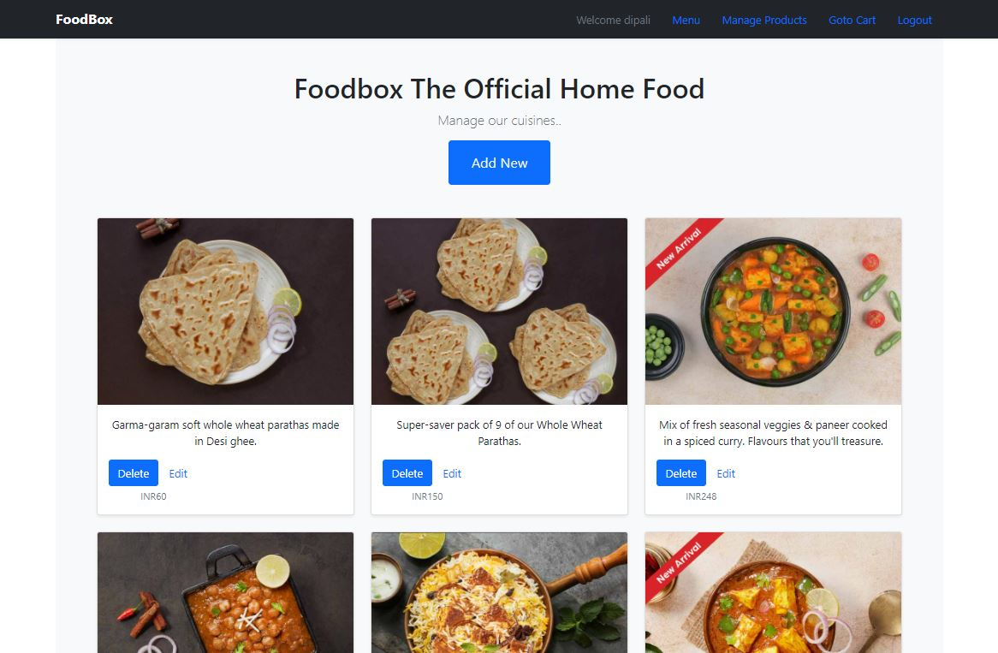

* 1. Add New product

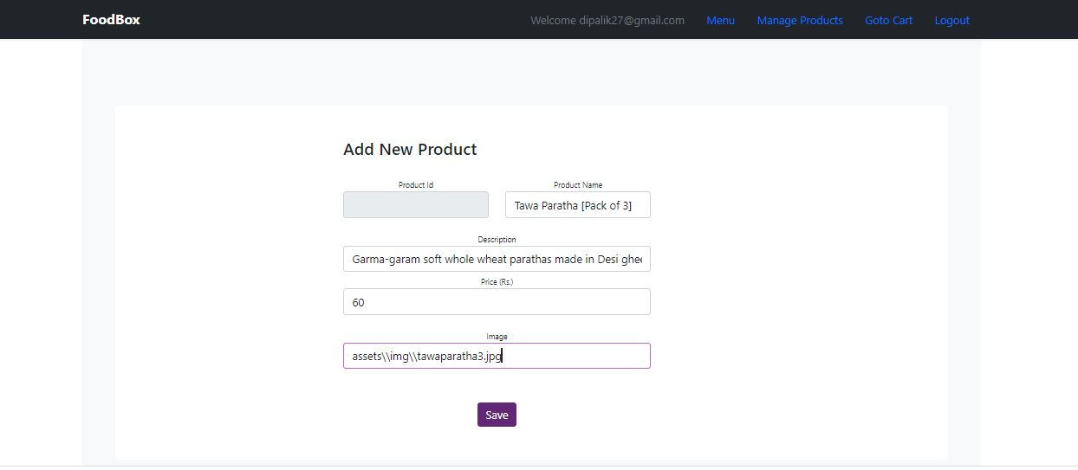

* 1. Edit product

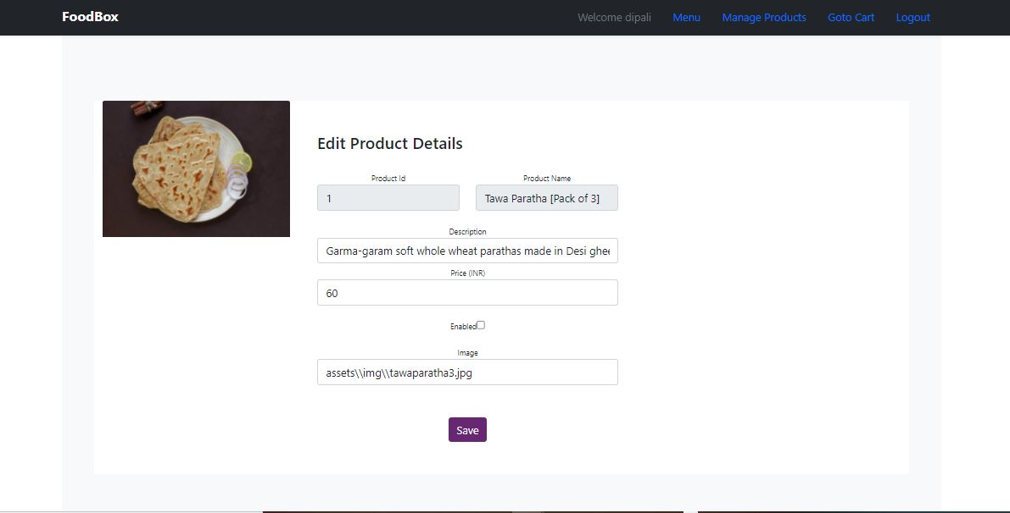

* 1. Menu

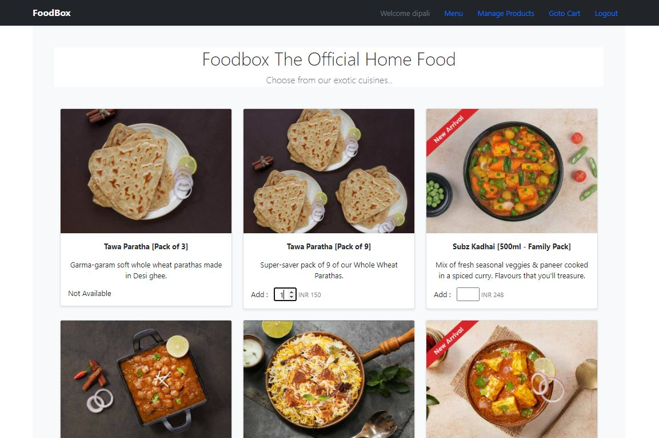

* 1. Goto Cart

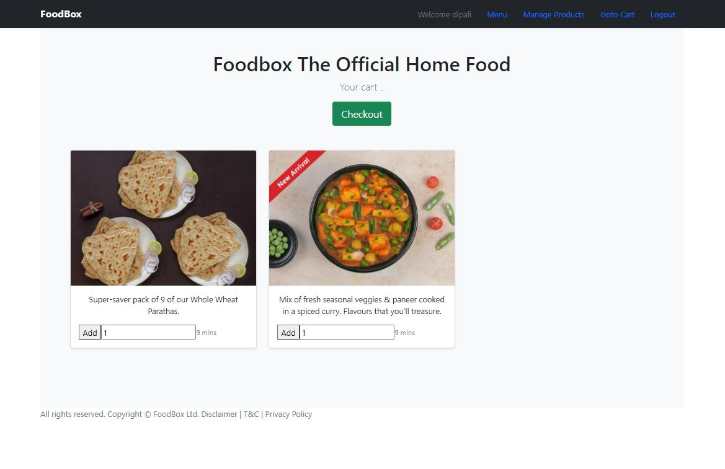

* 1. Checkout page

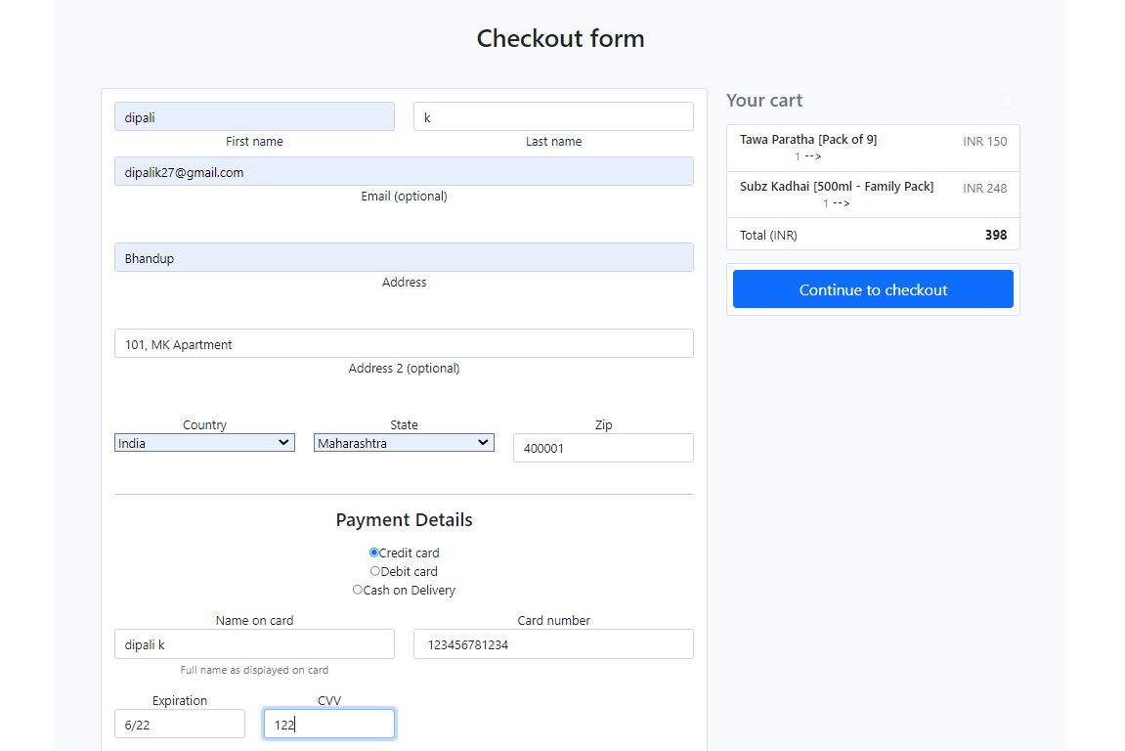

* 1. Success page

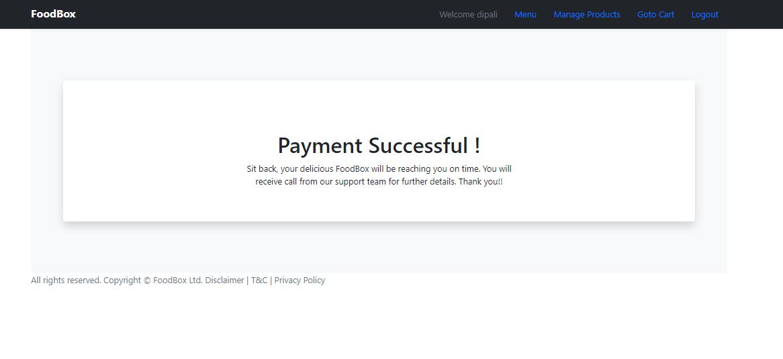

## Core Concepts and tools used in the project

1. Database management: MySQL
2. Backend logic: Spring Boot, JPA, JWT Authentication, RestAPI
3. Frontend development: Angular, Bootstrap
4. DevOps and production technologies: Git, GitHub, Docker and AWS

## Link to the GitHub repository

Link to GitHub repository for source code of the project is as below:

<https://github.com/sonalik27/foodbox-capstone-sonalip>

## Conclusion

This application provides interface for admin as well as non-admin users to manage the business data and/or view menu and checkout the order.

Further enhancements can be added to project as:

* Look and feel of the pages can be further enhanced.
* JUNIT5 test cases can be added for all the functionalities.